|  |
| --- |
|  |
| Cinema Management System  Ster-Kinekor Harare |
| |  |  |  | | --- | --- | --- | | Sammy Nyakabau | 1/19/18 |  | |

**SECTION A** 3

Backgound of The Study 3

Problem Definition 3

Investigation of current system 3

Data Analysis 3

Data collection methods 6

Problems with current system 9

Feasibility study 9

Requirements Specification 11

Hardware Requirements 11

Software Requirements 11

User Requirements 12

Aims 12

Objectives 13

**SECTION B** 14

Consideration of alternate methods 14

1. Improve The Current System 14

2. Buying Off the Shelf Package 14

3. Outsourcing/ Contracting 15

4. Bespoke/ In House Developments 15

Justification Of Chosen System 16

Object Oriented Design 16

Use Case Diagrams 17

Sequence Diagrams 18

Class Diagrams 19

**SECTION C** 20

Software Development 20

1. Login Code 20

2. Bookings Code 21

Technical Documentation 24

1. Pseudocodes 24

2. Flowcharts 25

User Documentation 26

1. Installing 26

2. Starting The System 28

3. Navigation Of The System (Visitor) 29

4. Navigation Of The System (Admin) 30

5. Exiting The System 32

**SECTION D** 33

System And User Testing 33

1. Standard Data 33

2. Extreme Data 35

3. Abnormal Data 37

Evaluation 38

1. Successes 38

2. Limitations 39

3. Opportunities 39

# **SECTION A**

## Backgound of The Study

A movie theatre (also called a cinema, movie house, film house, film theatre or picture house) is a venue, usually a building, for viewing movies (films). Most but not all movie theatres are commercial operations catering to the general public, who attend by purchasing a ticket. The movie is projected with a movie projector onto a large projection screen at the front of the auditorium. Most movie theatres are now equipped for digital cinema projection, removing the need to create and transport a physical film print

The Hollywood film Industry makes films and the films are screened in cinema houses across the world and later released on DVDs and Blu-rays for various homes. Ster-Kinekor (SK) is the leading movie centre in Zimbabwe and has exploded into a booming company in the last decade. It has two branches in Harare, that is at the heart of the CBD opposite Eastgate Mall and also it has another outlet at Sam Levy Shopping Mall. SK gets its movies from reputable movie production companies such as Marvel Studios, DC Movies, among others. These movies are then screened at stipulated times with customers having to purchase tickets so as to watch the movie. SK has now marketed all over Africa and the rest of the world but the seat reservation and management of movies needs to be computerised.

## Problem Definition

The popular movie centre SK has been thriving over the years and has seen the number of customers doubling, however their current system cannot support this growth and, due to the technological advancement, SK must keep up to remain competitive. SK faces security concerns over the use of old fashioned ticket system. In addition to that, there’s lack of knowledge to the public about the upcoming movies including the streaming and premier times. Furthermore, absence of an efficient booking system makes it difficult for customers as they must wait in line to buy a movie ticket and also strains the employees. Also, previews and trailers of movies can only be seen at the sight; customers have no interaction with the system off site. The lack of an efficient rating system has led to the subsequent growth in frustration from the public. Besides being one of the biggest companies, there’s been a sudden loss in customers due to the slowness of the current system. To cater for these problems, a user-friendly and interactive platform will be designed and it will help users interact with the system both online and offline. It will also help employees with quality control.

## Investigation of current system

### Data Analysis

#### Data Flow Diagrams (DFD)



#### Entity Relationship Diagram (ERD)

System Flowchart



### Data collection methods

#### Questionnaires



#### Interviews

Interview questions

#### with staff



#### with general manager



#### with customers



### Problems with current system

* **Security matters**: There’s no control of access thus the system can be compromised.
* **Consumes time**: it takes more time for a customer to book a ticket.
* **Number of workers**: many workers are involved in the booking ticket box and in e other related services which is expensive to the company due to wages and salaries.
* **Manual system**: The booking system is paper-based which increases data duplication and redundancy.
* **Managing**: it is difficult to manage in the case of a large number of customers coming leading to many workers being involved in the process.
* **Dependent on employee:** customers cannot book or pay for a movie without the assistance of staff

## Feasibility study

The aim of the study is to measure the benefits of the new system against the cost, that is, whether it is worth proceeding with the project or not.

***ECONOMIC FEASIBILITY***

Here the main purpose of the feasibility was to see if the cost incurred by the project would weigh against the benefits enjoyed from it, that is a cost benefit analysis.

**Cost**

*Equipment*: -at least two personal computers are to be bought to coincide with the software needed for the new system. Two printers are also needed to produce output. These are all require cash

*Development cost:* -these involve costs the hardware will incur during the development of the new system e.g. hiring of system analyst, designers, programmers and new software purchase

*Maintenance cost: -*these include costs incurred from hiring hardware engineers and all those who help in maintaining a good system.

*Training cost*-this the cost that arises due to hiring of tutors on who will train the staff on how to use the new system

*Operational cost: -*accessories like bond paper, ink cartridges and flash disk will be required frequently for efficient operation.

**Benefits**

* Better security and integrity of data can be achieved due to use of passwords in the system
* The need for update records will be easier to fulfil and thus data consistency is promoted
* To save time.
* Reduce resource wastage of ticket,
* Minimize large number of workers involved
* The various benefits thus prove that the system is economically feasible.

***OPERATIONAL FEASIBILITY***

This concerns the effects of the new system on staff, management and the customers and suppliers. The staff desires the change as they view it as an easier and technologically way of doing work, and the management believes it to be a better way of maintaining records at the hardware. the customers and suppliers are eager for the system to be implemented as this will serve they time and introduce fast services.

**Benefits**

* Relieves workload on staff
* Results in faster processing of transactions therefore customers are served faster
* Increases productivity as more customers can now be served in a short period of time

***TECHNICAL FEASIBILITY***

This was carried out to measure the technically of the solution and the availability of technical resources and expertise. This involves the effect of the new system on staff and organizational objectives and practices

The system is technically feasible since,

* The hardware required is readily available
* The system will be able to integrate with existing software since it will be platform-independent
* The system is user-friendly thus little to no user-training is required for employees or customers to scale through the system

## Requirements Specification

Mouse, PC, Printer

The Hardware and Software requirements of the proposed system are:

### Hardware Requirements

Physical Memory (RAM): 512MB minimum, 1GB recommended

Virtual Memory: Double the amount of RAM

Temp disk space: 100MB

Video adapter: 256 colours

Processor: 200MHz minimum

### Software Requirements

System Architecture: 64-bit

Operating System: Computerised Cinema Management System for Windows is supported on the following operating systems:

* Windows XP Professional
* Windows 7/8/10
* Windows Server 2008/2012

### User Requirements

Administrator**:**

* can be check movie details
* can be able to make a booking for a customer
* can add new customers
* can calculate change
* can print receipt
* can view existing bookings
* can view existing customers
* view their customer reservation order

A customer should be able to:

* login to the system without the need of a password.
* Check movie details
* Watch movie trailers.

## Aims

***EFFICIENCY***

* Efficiency will be increased since employees (admin) can now easily track bookings and payments made.

***SECURITY***

* Security will be ensured since customers can only enter a cinema if they have a gate pass which is obtained through payment
* Security will also be enhanced through the authentication of the admin account

***TIME SAVING***

* The number of customers being served per unit time will be increased through the use of this system

***USER FRIENDLY***

* The system will be user friendly since it will have a graphical user interface that comes with a manual on how to interact with the system

## Objectives

* Should allow the user to login to the system without the need of a password.
* It should facilitate the checking of movie details by users
* Users should be able to watch trailers
* The system should allow for administrators to add new customers, make bookings for customers, among other things
* Administrators should also be able to calculate change, view bookings and existing customers

# **SECTION B**

## Consideration of alternate methods

### Improve The Current System

* The current manual system will remain in operation and additional features added to it in the form of manpower and stationery. More members will be added to the current two to allow division of tasks and specialisation thereby improving the system performance.

#### **Advantages**

* Less expensive than acquiring and maintain a new readymade system.
* Fast method since there is no program time required.
* High management control since there is no external personnel involved in system development.
* It is possible to assess all costs in advance.

#### **Disadvantages**

* The problem of monotony will exist since there will be duplication of work.
* There will be little if not zero system security.
* High system inflexibility.
* Poor quality of receipts prepared manually.
* Data processing is very time consuming.
* Does not support granting of access privileges

### Buying Off the Shelf Package

* Purchasing an off the shelf application package means that the current system will be completely replaced by the acquired application. Off the shelf package is an application developed by the specialist Software Developers as standard programs to solve various related problems and it is tested. This means that they are not made to user requirements and specifications.

#### **Advantages**

* Fast method since no programming time is required.
* It is fully guaranteed; that is an off the shelf package is tried and tested.
* It has better documentation.
* Support regular updates and readily available from suppliers.

#### **Disadvantages**

* Does not perfectly meet user requirements since it was developed without user specifications.
* Purchaser lacks control over the application.
* It is expensive to acquire readymade software and total back up.
* Data loss can be experienced in introducing the system.
* Comprehensive training is required to all the system users.
* There is high system inflexibility.
* Program maintenance is difficult since the application is supplied without source code and design.

### Outsourcing/ Contracting

* It is a contractual relationship where an external organisation takes responsibility for performing an agency information technology functions in totality or partiality. This can involve partial or complete transfer of staff and resources.

#### **Advantages**

* Allows transfer of expertise.
* It allows access to technology.
* It can reduce both fixed and recurrent costs.

#### **Disadvantages**

* Less managerial control.
* More expensive especially when there is transfer of expertise.
* Lack of flexibility.
* Security and confidential can be compromised.
* There are high chances of taking the process back in house or changing service provider when the outsourcing company goes bankrupt or out of business.

### Bespoke/ In House Developments

* In house development of the new system will be based on the user requirements. This computer based system will address the problems associated with the current system and will completely replace it.

#### **Advantages**

* A suitable solution is developed that will solve the problems and pass user acceptance test since the system is designed based on user requirements.
* The existing system problems will be dealt with since they are precisely defined.
* Proper control and security measures will be induced in the system during development.
* Low maintenance cost since developers from PSDT will be providing support.
* It is possible to access all costs in advance.
* Supports system security and confidential of information.

#### **Disadvantages**

* It is time consuming since good software needs enough development time.
* Require more programming time.
* Problem of required resources and skills encountered.

### Justification Of Chosen System

* The development of the desired Cinema Management System has been considered the most appropriate solution due to a number of factors put into consideration which are as follows:
* High system flexibility.
* There is granting of access privileges hence better security.
* Cheap to acquire with total back up facilities.
* High management control since there is no external personnel involved in system development.
* Fast method since there is no program time required.
* There is no duplication of work.
* Supports system security and confidentiality of information.
* Allows transfer of expertise.
* It allows access to technology.
* It can reduce both fixed and recurrent costs

## Object Oriented Design

### Use Case Diagrams

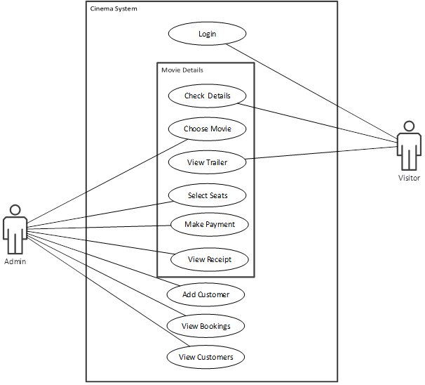

#### ***Check Movie Details***

* On this scenario the visitor (user) can check to see the title of the movie and where the movie is going to be screened i.e. Cinema number

#### ***Choose Movie***

* On this scenario, the admin can select a movie for a customer basing on the customer’s preference

#### ***View Trailer***

* The visitor/customer can view any movie trailer anywhere, anytime!

#### ***Select Seats***

* The admin selects the preferred seat of the customer from an array of available seats in the auditorium

#### ***Make Payment***

* The customer can now make a payment through the admin at the POS Terminal

#### ***View Receipt***

* A receipt preview is initiated after the payment has been made and now the visitor is now able to see the details of the transactions

#### ***Add Customer***

* In the event of a new customer coming to make a booking, the admin can now add that customer to the database of existing customers

#### ***View Existing Bookings***

* The admin can view the existing bookings (red seats) in a every cinema and can also see the owner if the seat

#### ***View Customers***

* The admin can view the existing customers of the system and their details

### Sequence Diagrams



### Class Diagrams



# **SECTION C**

## Software Development

### Login Code

***Public* *Class* *LoginInfo***

***' Declaring variables to capture username and password***

***Dim* *username* *As* *String***

***Dim* *password* *As* *String***

***' timer that shows the day's time and date***

***Private* *Sub* *Timer1_Tick(sender* *As* *Object,* *e* *As* *EventArgs)* *Handles* *Timer1.Tick***

***lblTime.Text* *=* *TimeOfDay***

***End* *Sub***

***Private* *Sub* *Login_Load (sender* *As* *Object,* *e* *As* *EventArgs)* *Handles* *MyBase.Load***

***'TODO: This line of code loads data into the 'UsersDataSet.Admin' table. You can move, or remove it, as needed.***

***Me. AdminTableAdapter.Fill(Me. UsersDataSet.Admin)***

***Timer1.Start()***

***lblDate.Text* *=* *Date.Today***

***End* *Sub***

***' method that clears the textboxes***

***Public* *Sub* *Clear ()***

***txtPassword.Clear()***

***txtUsername.Clear()***

***End* *Sub***

***Private* *Sub* *btnLogin_Click (sender* *As* *Object,* *e* *As* *EventArgs)* *Handles* *btnLogin.Click***

***Start:***

***' assigning the entered credentials to variables***

***password* *=* *txtPassword.Text***

***username* *=* *txtUsername.Text***

***' comparing the entered credentials with records stored in the database***

***If* *Me. AdminTableAdapter.ScalarQueryAdmin(username,* *password)* *Then***

***Me. Hide ()***

***Menu_Admin.Show()***

***Else***

***MessageBox.Show("Invalid Username And/Or Password",* *"Error",* *MessageBoxButtons.RetryCancel,* *MessageBoxIcon.Exclamation)***

***If* *DialogResult* *=* *DialogResult.Retry* *Then***

***Clear ()***

***GoTo* *Start***

***End* *If***

***End* *If***

***End* *Sub***

***' this method takes customers through the system***

***Private* *Sub* *LinkLabel1_LinkClicked (sender* *As* *Object,* *e* *As* *LinkLabelLinkClickedEventArgs)* *Handles* *linkVisitor.LinkClicked***

***Me. Hide ()***

***Menu_Visitor.Show()***

***End* *Sub***

***End* *Class***

### Bookings Code

***Public* *Class* *Cinema1***

***' global variables to store program identifiers***

***Dim* *availableIcon* *As* *New* *System.Drawing. Bitmap (Me. Resources.available)* *'getting icons to show seat status***

***Dim* *provisionalIcon* *As* *New* *System.Drawing. Bitmap (Me. Resources.provisional)***

***Dim* *bookedIcon* *As* *New* *System.Drawing. Bitmap (Me. Resources.booked)***

***Dim* *bookedSeats,* *availableSeats,* *provisionalSeats* *As* *Integer***

***Public* *totalCost,* *totalPayment,* *change,* *seats* *As* *Integer***

***Public* *customerID* *As* *String***

***Public* *firstName* *As* *String***

***Const* *COST* *=* *5* *'the cost of one seat***

***' this method saves and commits to the database the selected seats***

***Private* *Sub* *btnSave_Click (sender* *As* *Object,* *e* *As* *EventArgs)* *Handles* *btnSave.Click***

***Dim* *c* *As* *Control***

***Dim* *bSelected* *As* *Boolean***

***For* *Each* *c* *In* *Me. Controls* *'this loop iterates until it reaches a selected seat***

***If* *TypeOf* *(c)* *Is* *PictureBox* *Then***

***If* *CType (c,* *PictureBox). Image* *Is* *provisionalIcon* *Then***

***bSelected* *=* *True***

***Exit* *For***

***End* *If***

***End* *If***

***Next***

***If* *bSelected* *=* *False* *Then***

***MessageBox.Show("Please select at least one seat to book",* *"Error",* *MessageBoxButtons.RetryCancel,* *MessageBoxIcon.Warning)***

***End* *If***

***Dim* *stSQLInsert* *As* *String***

***Dim* *stConString* *As* *String* *=* *"Provider = Microsoft.ACE.OLEDB.12.0; Data Source = "* *&* *Application.StartupPath* *&* *"\Cinema 1.accdb"***

***Dim* *conBookings* *As* *OleDb.OleDbConnection***

***conBookings* *=* *New* *OleDb.OleDbConnection***

***conBookings.ConnectionString* *=* *stConString***

***conBookings.Open()***

***Dim* *cmdMakeBookings* *As* *OleDb.OleDbCommand* *=* *New* *OleDb.OleDbCommand***

***cmdMakeBookings.Connection* *=* *conBookings***

***Dim* *iSeatNum* *As* *Integer***

***For* *Each* *c* *In* *Me. Controls***

***If* *TypeOf* *(c)* *Is* *PictureBox* *Then***

***If* *CType (c,* *PictureBox). Image* *Is* *provisionalIcon* *Then***

***iSeatNum* *=* *Mid (CType (c,* *PictureBox). Name,* *11)***

***stSQLInsert* *=* *"INSERT INTO tblBookings (Customer, Seat) VALUES ('"* *&* *txtID.Text* *&* *"',"* *&* *iSeatNum* *&*”)” *'inserting selected seat number into table***

***cmdMakeBookings.CommandText* *=* *stSQLInsert***

***cmdMakeBookings.ExecuteNonQuery()***

***End* *If***

***End* *If***

***Next***

***customerID* *=* *txtID.Text***

***firstName* *=* *txtFirstName.Text***

***conBookings.Close()***

***Call* *updateBookings ()***

***MessageBox.Show("The Booking Was Successfull!",* *"Success",* *MessageBoxButtons.OK,* *MessageBoxIcon.Information)***

***Receipt1.Show()***

***End* *Sub***

***’ calculating change***

***Private* *Sub* *btnCalculateChange_Click (sender* *As* *Object,* *e* *As* *EventArgs)* *Handles* *btnCalculateChange.Click***

***Start:***

***totalPayment* *=* *txtTotalPayment.Text***

***If* *totalPayment* *>=* *totalCost* *Then***

***change* *=* *totalPayment* *-* *totalCost***

***txtChange.Text* *=* *("$")* *&* *(change). ToString***

***Else***

***MessageBox.Show("Please make enough payment to proceed",* *"Error",* *MessageBoxButtons.OK,* *MessageBoxIcon.Warning)***

***GoTo* *Start***

***End* *If***

***End* *Sub***

***’ this method loads the form with the number of seats available, booked by communicating with the database***

***Private* *Sub* *Cinema1_Load (sender* *As* *Object,* *e* *As* *EventArgs)* *Handles* *Me. Load***

***Dim* *c* *As* *Control***

***For* *Each* *c* *In* *Me. Controls***

***If* *TypeOf* *(c)* *Is* *PictureBox* *Then***

***If* *c. Name* *=* *"NameBox"* *Or* *c. Name* *=* *"Background"* *Then***

***Continue* *For***

***End* *If***

***CType (c,* *PictureBox). Image* *=* *availableIcon***

***AddHandler* *c. Click,* *AddressOf* *PictureBox10_Click***

***End* *If***

***Next***

***availableSeats* *=* *160***

***bookedSeats* *=* *0***

***provisionalSeats* *=* *0***

***Call* *updateBookings ()***

***End* *Sub***

***'viewing reservations***

***Private* *Sub* *btnViewReservations_Click (sender* *As* *Object,* *e* *As* *EventArgs)* *Handles* *btnViewReservations.Click***

***ReservedSeats.Show()***

***End* *Sub***

***'viewing existing bookings***

***Private* *Sub* *btnExisting_Click (sender* *As* *Object,* *e* *As* *EventArgs)* *Handles* *btnExisting.Click***

***Customers1.Show()***

***End* *Sub***

***'adding a new customer***

***Private* *Sub* *btnNew_Click (sender* *As* *Object,* *e* *As* *EventArgs)* *Handles* *btnNew.Click***

***AddCustomer1.Show()***

***End* *Sub***

***Sub* *updateBookings ()* *' this method loads the application with data from the database***

***availableSeats* *=* *160* *-* *bookedSeats* *'getting the number of available seats***

***provisionalSeats* *=* *0***

***Dim* *strSQL* *As* *String* *=* *"SELECT * FROM tblBookings"***

***Dim* *stConString* *As* *String* *=* *"Provider = Microsoft.ACE.OLEDB.12.0; Data Source = "* *&* *Application.StartupPath* *&* *"\Cinema 1.accdb"***

***Dim* *conBookings* *As* *OleDb.OleDbConnection***

***conBookings* *=* *New* *OleDb.OleDbConnection***

***conBookings.ConnectionString* *=* *stConString***

***conBookings.Open()***

***Dim* *cmdSelectBookings* *As* *OleDb.OleDbCommand* *=* *New* *OleDb.OleDbCommand***

***cmdSelectBookings.CommandText* *=* *strSQL***

***cmdSelectBookings.Connection* *=* *conBookings***

***Dim* *dsBookings* *As* *New* *DataSet***

***Dim* *daBookings* *As* *New* *OleDb.OleDbDataAdapter(cmdSelectBookings)***

***daBookings.Fill(dsBookings,* *"Bookings")***

***conBookings.Close()***

***Dim* *t1* *As* *DataTable* *=* *dsBookings.Tables("Bookings")***

***Dim* *row* *As* *DataRow***

***For* *Each* *row* *in* *t1. Rows* *'this loop gets all the booked seats and updates the interface***

***CType (Controls ("PictureBox"* *&* *row (2)),* *PictureBox). Image* *=* *bookedIcon***

***bookedSeats* *+=* *1***

***availableSeats* *-=* *1***

***Next***

***txtBooked.Text* *=* *bookedSeats***

***txtAvailable.Text* *=* *availableSeats***

***txtProvisional.Text* *=* *provisionalSeats***

***Call* *clear ()***

***End* *Sub***

***Private* *Sub* *PictureBox10_Click (sender* *As* *Object,* *e* *As* *EventArgs)* *'setting colors to differentiate between booked seats and available seats***

***If* *CType (sender,* *PictureBox). Image* *Is* *availableIcon* *Then***

***CType (sender,* *PictureBox). Image* *=* *provisionalIcon***

***provisionalSeats* *+=* *1***

***availableSeats* *-=* *1***

***ElseIf* *CType (sender,* *PictureBox). Image* *Is* *provisionalIcon***

***CType (sender,* *PictureBox). Image* *=* *availableIcon***

***provisionalSeats* *-=* *1***

***availableSeats* *+=* *1***

***End* *If***

***txtAvailable.Text* *=* *availableSeats***

***txtProvisional.Text* *=* *provisionalSeats***

***seats* *=* *provisionalSeats***

***txtSeats.Text* *=* *seats***

***totalCost* *=* *provisionalSeats* *\** *COST***

***txtTotalCost.Text* *=* *("$")* *&* *totalCost.ToString***

***End* *Sub***

***'clearing the textboxes***

***Sub* *clear ()***

***txtTotalPayment.Clear()***

***txtFirstName.Clear()***

***txtTotalCost.Clear()***

***txtChange.Clear()***

***txtSeats.Clear()***

***txtID.Clear()***

***End* *Sub***

***End* *Class***

## Technical Documentation

### Pseudocodes

#### ***Booking***

Select seat

IF seat <> booked THEN

availableseats = availableseats -1

bookedseats = bookedseats + 1

SAVE TO DATABASE

END IF

#### ***Make Payment***

totalcost, totalpayment, change, seats: Integer

COST: Constant

totalcost = seats * COST

IF totalpayment <> 0 THEN

change = totalpayment – totalcost

Print Receipt

END IF

### Flowcharts

#### ***Booking***



#### ***Make Payment***



## User Documentation

### Installing

* The software is installed by clicking the setup

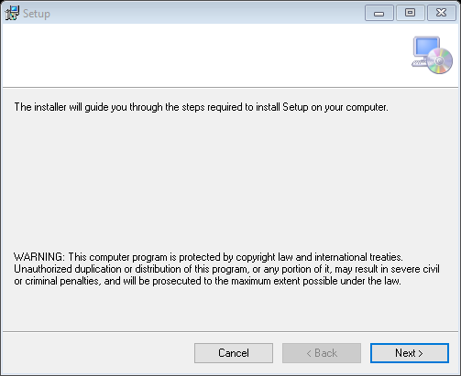

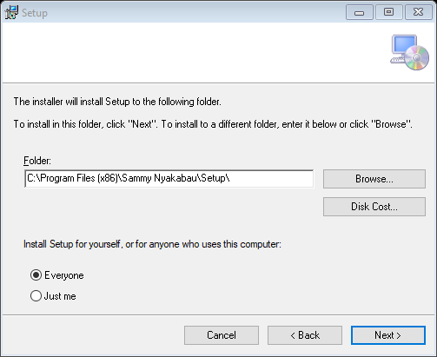

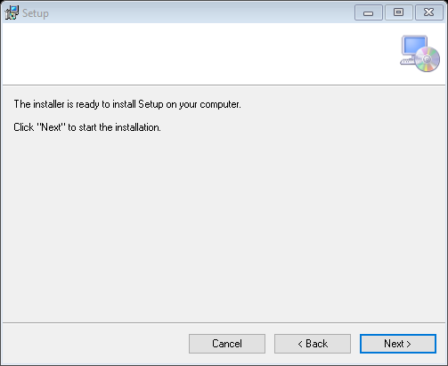

### Starting The System

* After setup is complete, a shortcut is added to the user’s desktop
* Double clicking the shortcut produces the following form

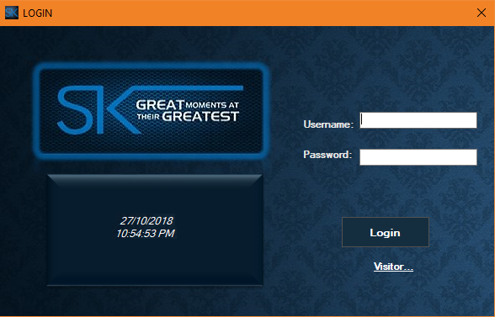

### Navigation Of The System (Visitor)

* After clicking the Visitor link, this menu forms comes up giving the user a view on all the movies on show
* The user can also choose to view any trailer of his choice as shown

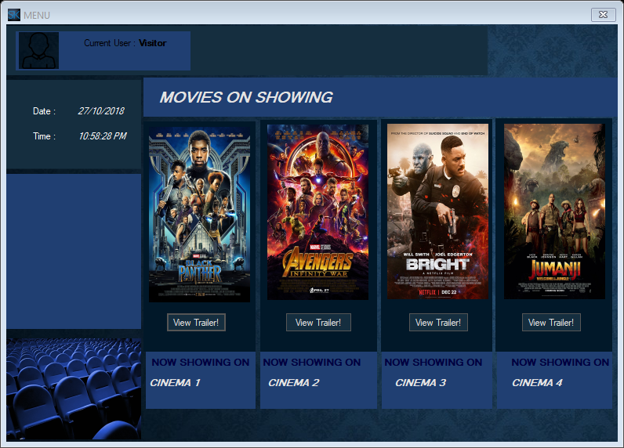

* After Clicking the View Trailer Button

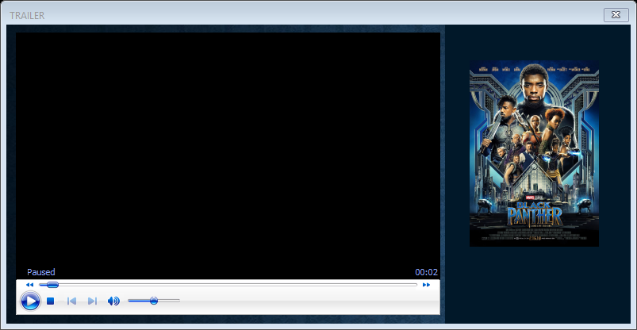

### Navigation Of The System (Admin)

* After entering the required parameters and after all verification, the main menu form comes up
* Here the Admin can view all the movies that are on showing and their respective cinemas
* The Admin can also book the seats for customers

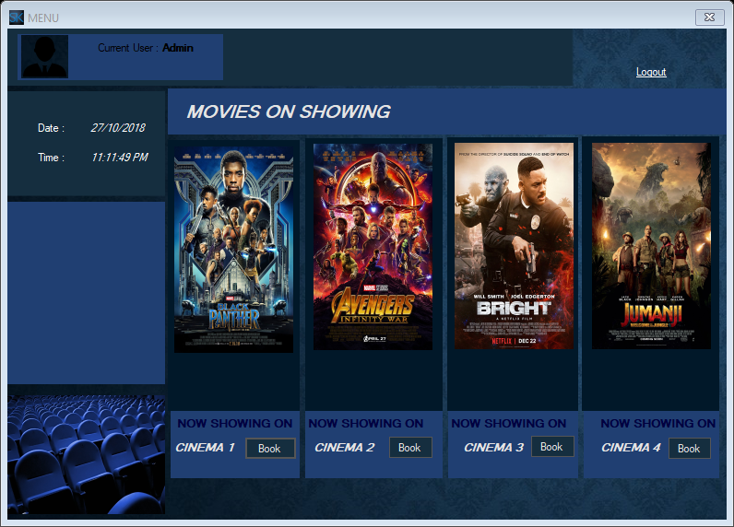

* After clicking the “Book” button

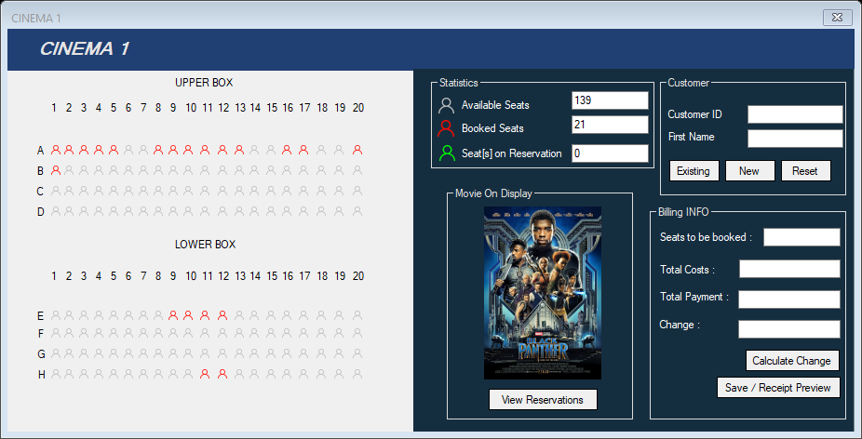

* On this form, the Admin can select particular seats for customers
* The Admin can also view existing bookings from customers by clicking the “View Reservations Button”
* 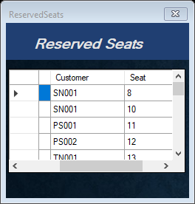
* Furthermore, the Admin can also Add New Customers by clicking the “New” button
* 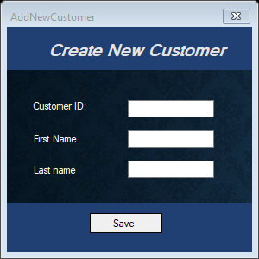

### Exiting The System

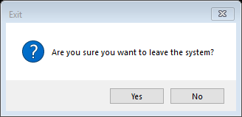

# **SECTION D**

## System And User Testing

### Standard Data

* The number of seats selected for booking is more than 0
* The total payment is greater than the total cost.

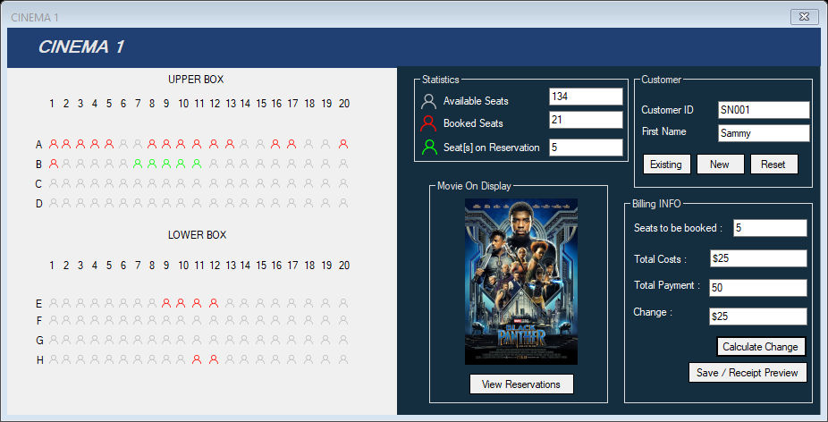

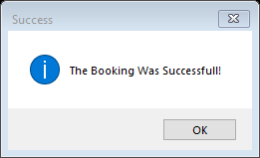

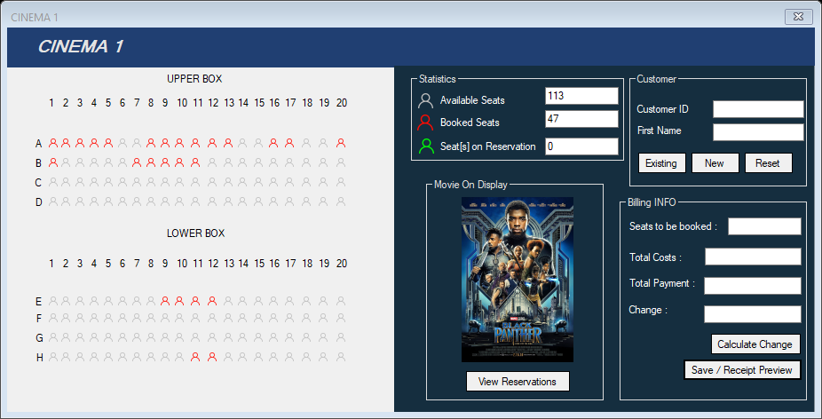

**NB**. The selected seats have all now turned from green to red to indicate a booking and the number of booked seats has increased (available seats have decreased)

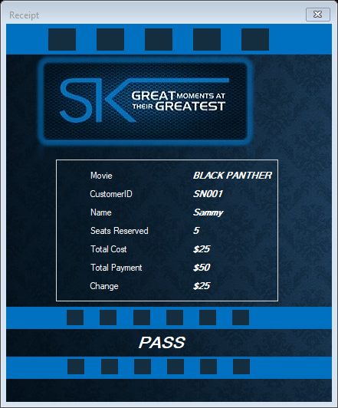

### Extreme Data

* Since the total payment should not be lower than the total cost therefore a payment in extremities would be equal to the total cost
* The number of booked seats should also never be less than 1 therefore, a single booking would lie in the extremities

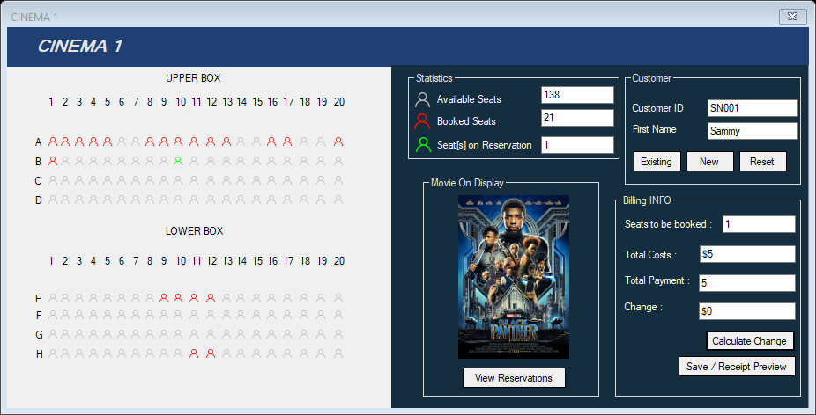



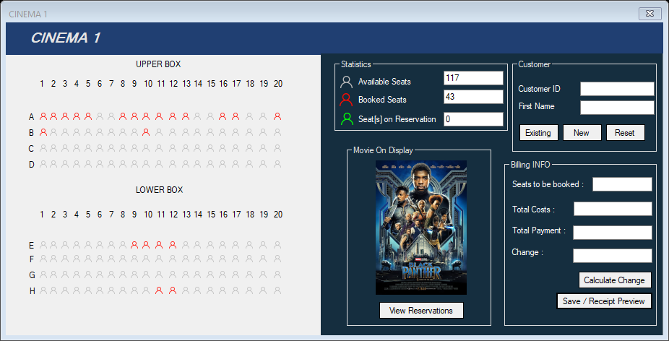

**NB**. The selected seats have all now turned from green to red to indicate a booking and the number of booked seats has increased (available seats have decreased)

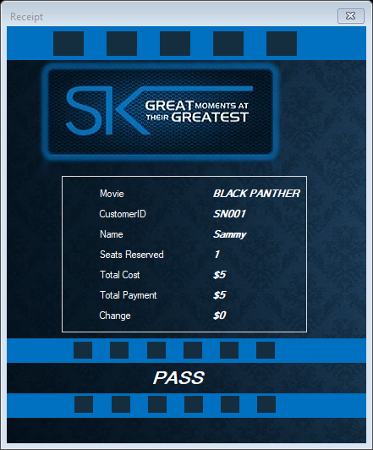

### Abnormal Data

* Here the number of seats booked will be less than 1

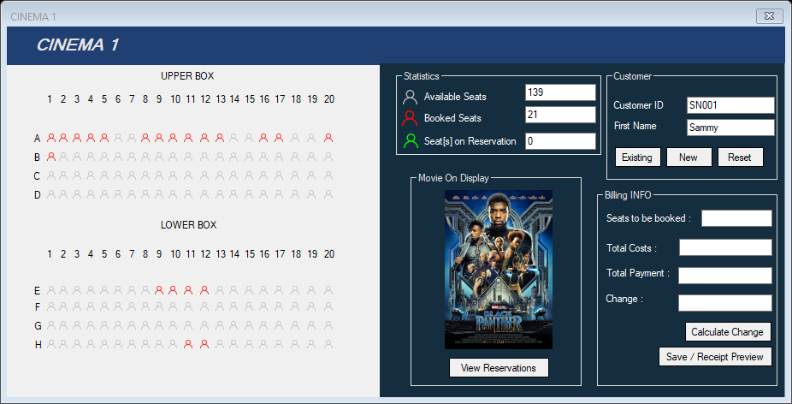

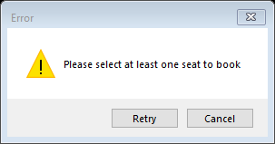

* Abnormal data can also arise when the total cost is greater than the total payment

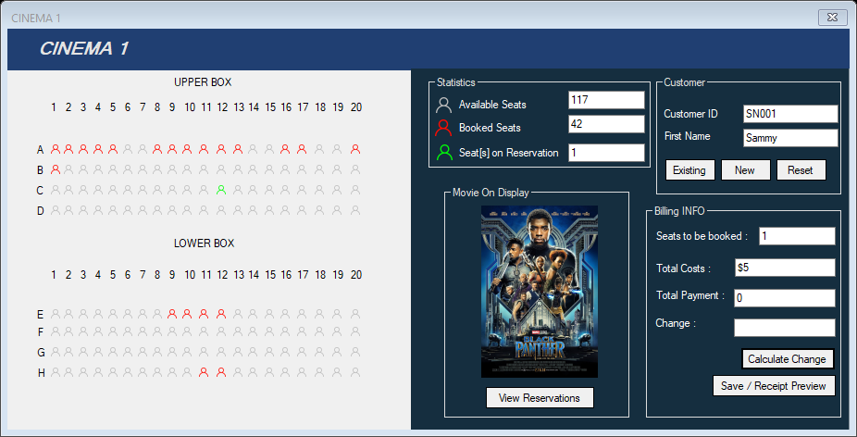

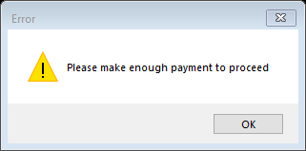

## Evaluation

### Successes

* The program outputs intended results for various forms of input
* The software is bug-free
* The software allows for customers to be updated about upcoming movies off-site
* The software facilitates the preview of movies by customers off-site through the use of trailers
* The system promotes security through user-authentication
* The system is accommodating: you don’t need an account to be able to view movie details
* The software makes it easier for the admin to track bookings and also payments thus transparency is increased
* The software leads to greater productivity as people can now be served on time.

### Limitations

* The Cinema forms take too long to load.

### Opportunities

* The system should be improved by adding a feature which allows for off-site payments
* The system can also be improved by making a mobile app version of it.